1. Using R for Introductory Statistics

2.

|  |  |  |
| --- | --- | --- |
| Pages | ((Endingpage+1)-beginningpage)/2 | Thickness(mm) |
| 115-196 | 41 | 5 |
| 203-258 | 28 | 3 |
| 85-226 | 71 | 8 |
| 91-244 | 77 | 9 |
| 51-240 | 95 | 10 |
| 43-274 | 116 | 13 |
| 15-220 | 103 | 12 |
| 121-268 | 74 | 8 |
| 147-208 | 31 | 3 |
| 211-296 | 43 | 5 |
| 21-176 | 78 | 9 |
| 27-144 | 59 | 6 |
| 111-300 | 95 | 11 |
| 71-254 | 92 | 10 |
| 171-292 | 61 | 7 |
| 33-98 | 33 | 4 |

3. Here is the plot where x = column 1, y = column 2:

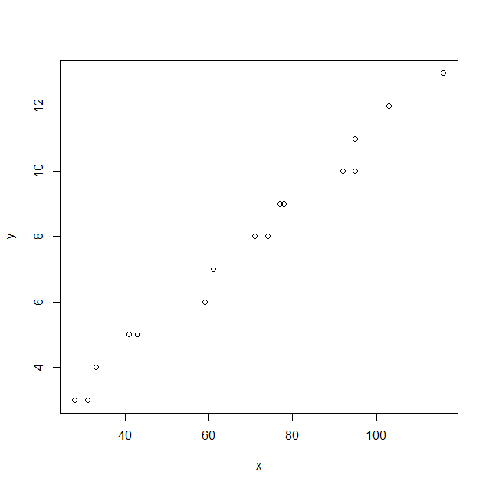

The correlation coefficient is 0.9929564. The Data seems to look quite linear, as pages should be uniform.

5.

Call:

lm(formula = Y ~ X)

Coefficients:

(Intercept) X

0.04313 0.11089

Coefficients:

Estimate Std. Error t value Pr(>|t|)

(Intercept) 1.2526 2.2701 0.552 0.59

y 8.7639 0.2747 31.908 1.78e-14 ***

6. The meaning of the slope is to show the thickness per page. With this you can predict sizes of sets of pages at will.

7. y = 0.1125569x + 0.03671683

10 pages = 1.16228583

8. The residual for the first data point is .4104436